TEAM?OARS

Step by Step Tutorial on How to Create our TEAM PROJECT WEB APPLICATION

Version 1.0

Signature Block

COSC 4351 | Name Signature | Date
SE Team Leader
SE SQA
Our TEAM?OARS is using the following technologies:

(e.g., C# Visual Studio IDE MVC2 framework and MS SQL SERVER DBMS;
PYTHON PyCharm IDE Django framework and mySQL DBMS;
PHP PhpStorm IDE Zend framework and mySQL DBMS)

The following steps will be used by TL to create TEAM?OARS web app and add it to the SVN for our team.

These are the steps to create the TEAM?OARS web site (to include the links to the needed downloads):

Step 1:
Download WAMP
http://www.wampserver.com/en/#download-wrapper
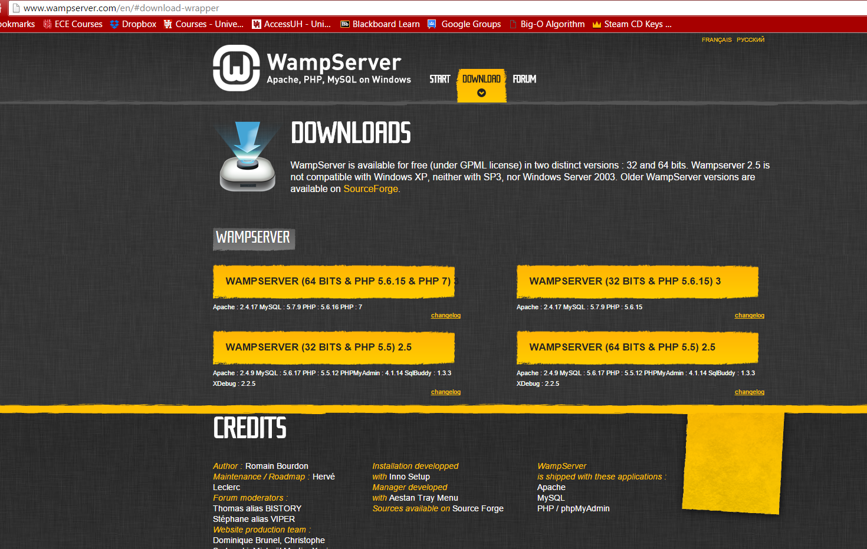
After downloading, make sure WAMP is running Online
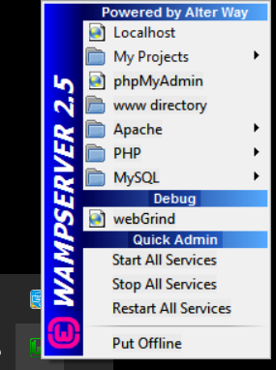
WAMP Server runs on port 88
http://localhost:88

Step 2:
Download Zend Framework 1.12.17 Minimal
http://framework.zend.com/downloads/latest
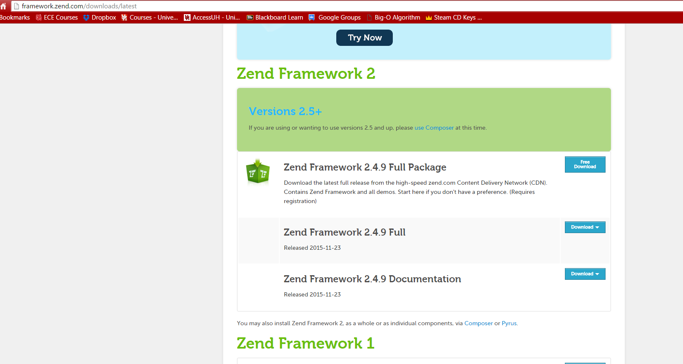

Step 3:
Unzip your Zend Frame work folder to C:WAMP\bin\php\zendFramework (whatever you have your file locate at)
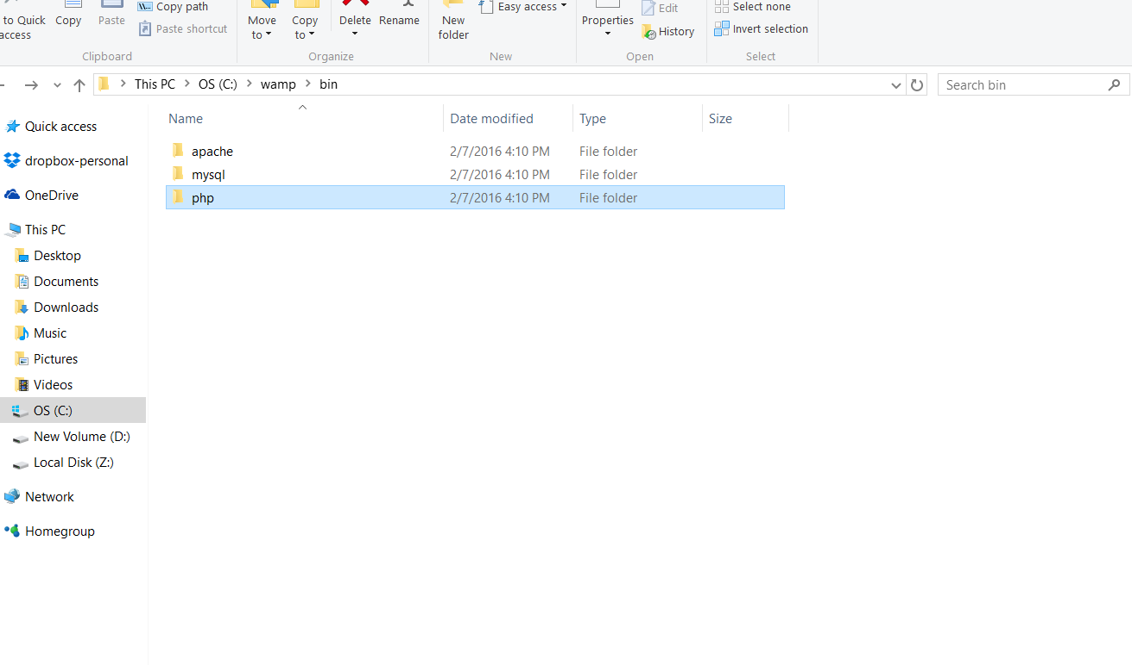
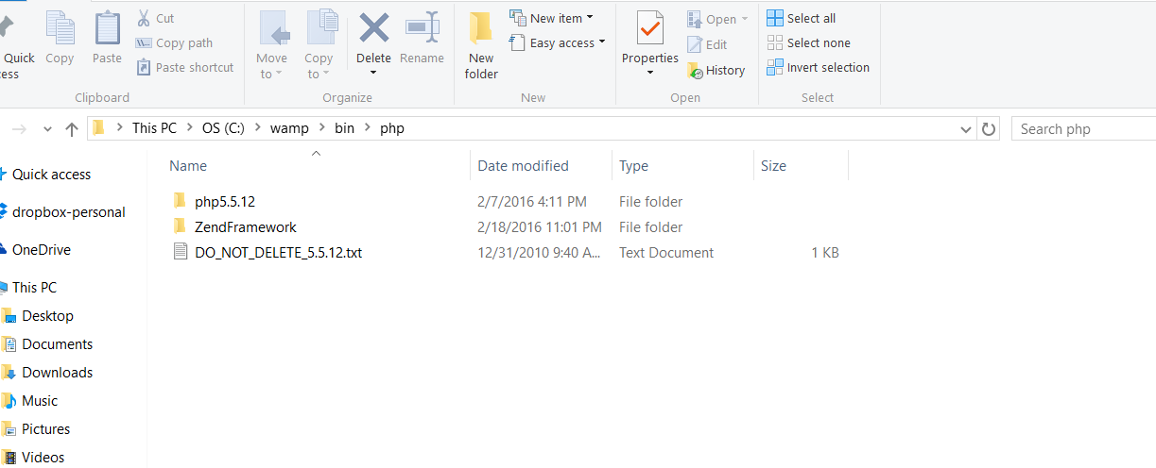

Step 4:
Open WAMP to php.ini file; and search include_path
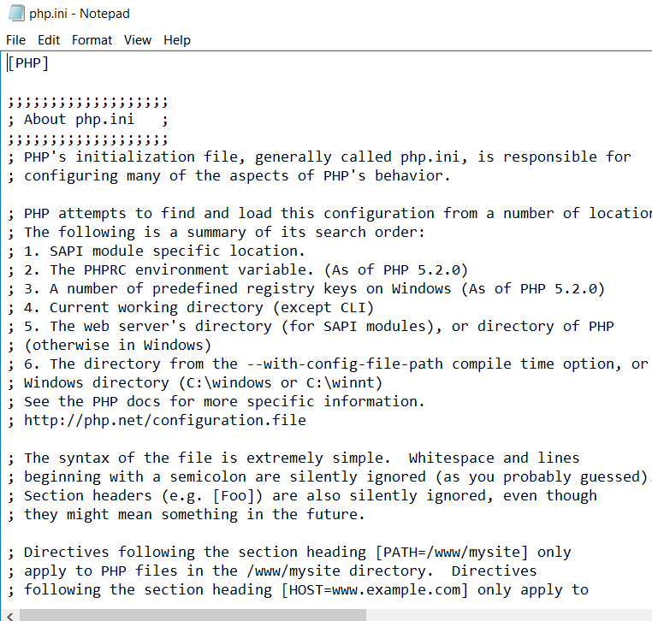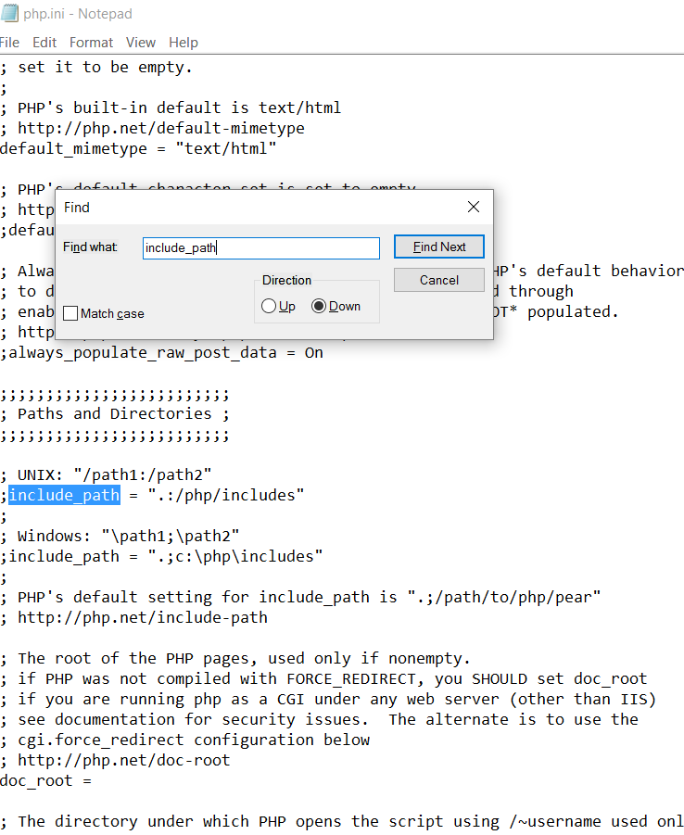

Add Framework library in the php Path
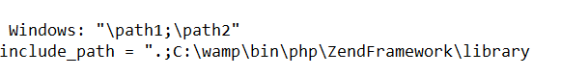

Step 5:
Add Zend to system path
Go to
- computer properties
- Advanced System Setting
- Environment Variable
- Path

Not sure we suppose to this step or not

Step 6:
Install Zend in NetBeans 6.9.1
Open NetBeans find Option under Tools tab
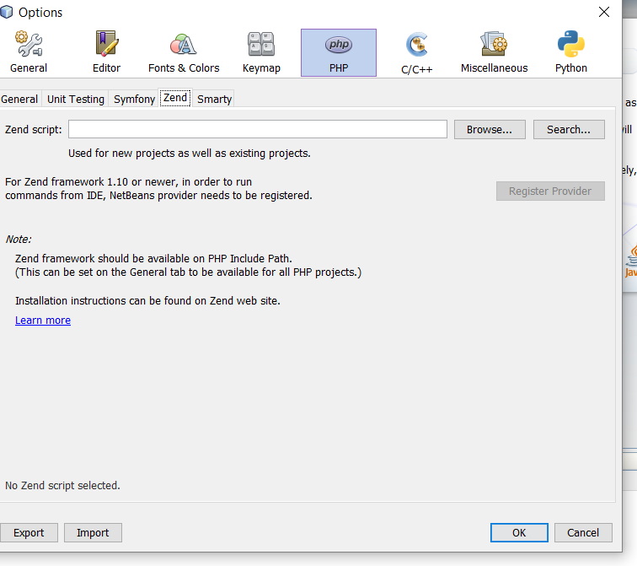
Click on search and ok
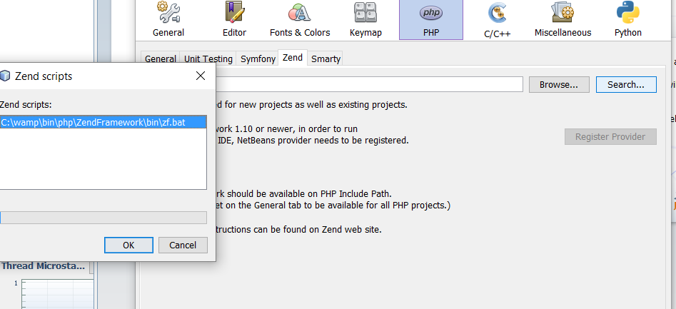

Register Provider

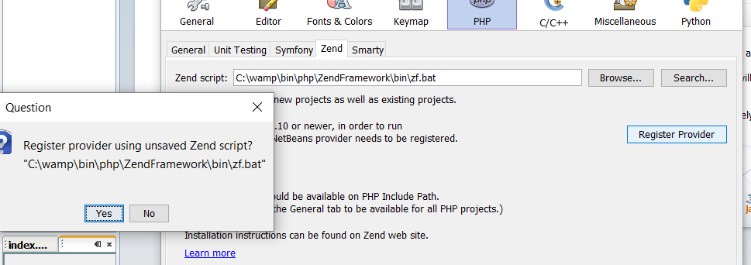

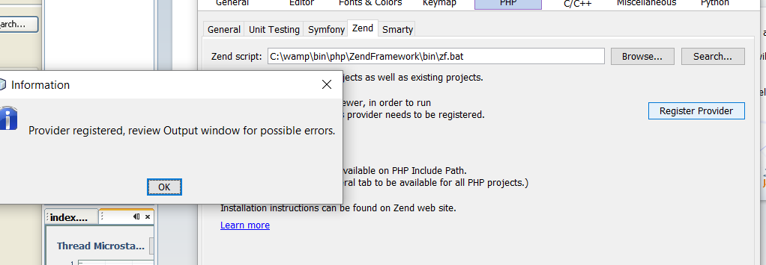

Step 7:
Create a Zend Framework on NetBeans 6.9.1
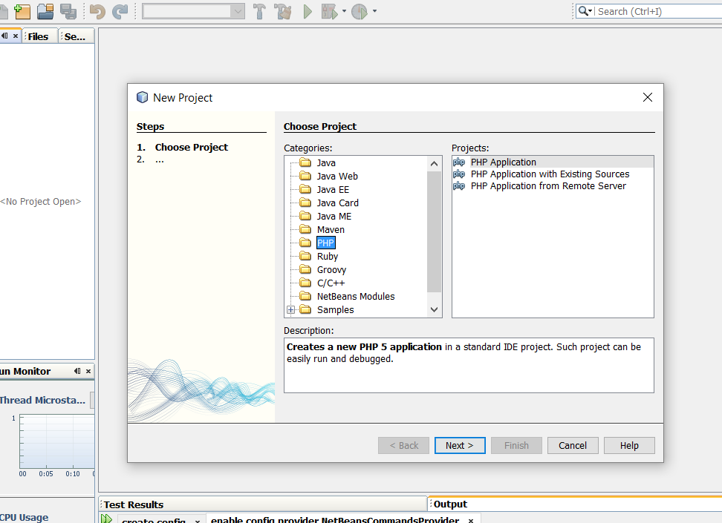
Make sure you select WAMP folder
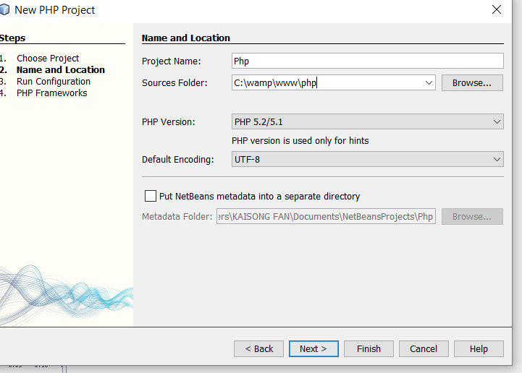

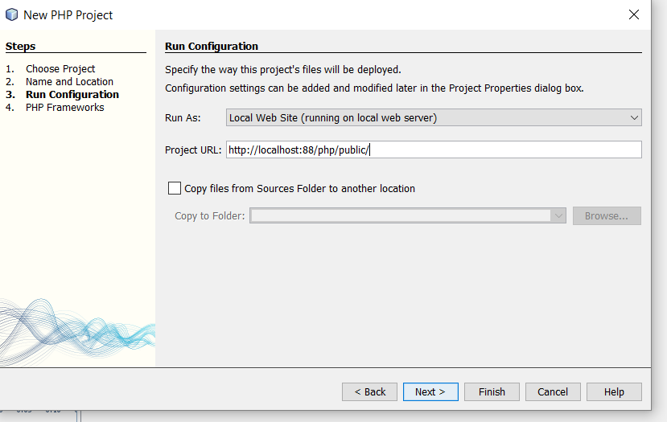
Select Zend PHP Web Framework then Finish
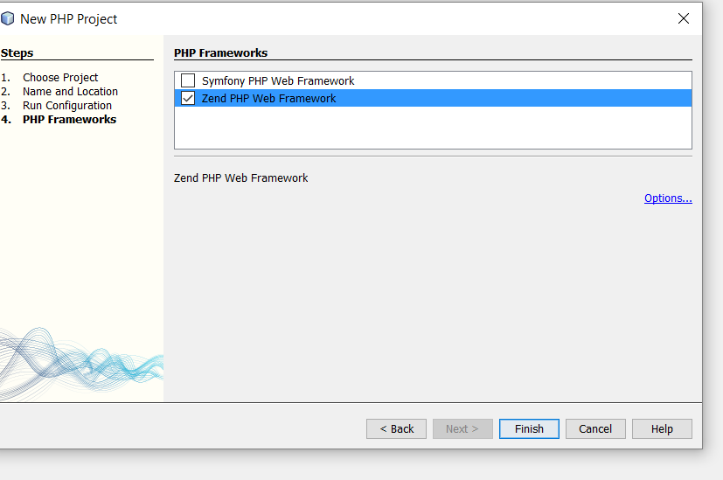

NOT SUPPOSE TO HAVE THIS

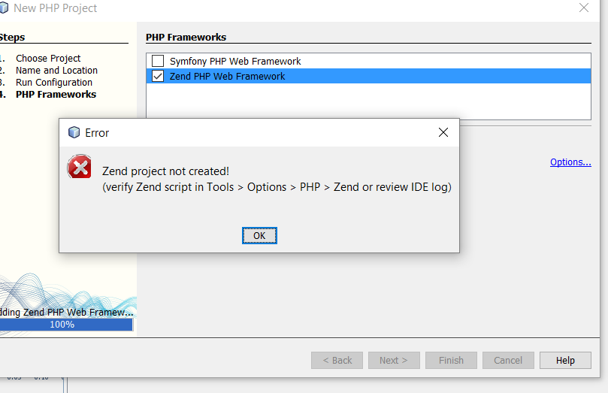

Document Control

Change History

Change History
(PLEASE REMOVE THIS BEFORE COMMITTING TO SVN!
NOTE: Team Leaders should place the TMs and ALL SQAs Names, Due Dates, Description BEFORE this document is released in SVN to TMs, DBAs, SQA!)

Table 1: TLs entries (assigned work and due dates) before releasing to the team
Revision | Name | Due Date | Description
1.A | TM & Name | XX/XX/XXXX | Add your work to Document
1.B | TM & Name | XX/XX/XXXX | Add your work to Document
1.C | DBA & Name | XX/XX/XXXX | Add your work to Document
1.X | SQA Name | XX/XX/XXXX | Review Document

Table 2: Entries when work completed (SVN Commit Comment matches Description)
Revision | Name | Completed Date | Description
1.A | TM & Name | XX/XX/XXXX | I …..
1.B | TM & Name | XX/XX/XXXX | I …..
1.C | DBA & Name | XX/XX/XXXX | I …..
1.X | SQA & Name | XX/XX/XXXX | I reviewed Document

(PLEASE REMOVE THIS BEFORE COMMITTING TO SVN!
NOTE: At the time of RED TEAMS DELIVERABLES, the Team Leaders should change the version on the COVER PAGE to 2.0 BEFORE COMMITTING back to SVN!!! Thus the last entry in CHANGE HISTORY should be the TLs)

Table 3: TL entry for RED DELIVERABLES (SVN Commit Comment matches Description)
Revision | Name | Due Date | Description
2.0 | TL & Name | XX/XX/XXXX | I changed Version to 2.0

Document Storage
This file is stored in SVN at https://svn.cs.uh.edu/svn/cosc4351/team?/TEAM PROJECT DELIVERABLES/Step by Step Tutorial on How to Create our TEAM PROJECT WEB APPLICATION.doc.

